Transition Assessments: (Must have the specific assessment name and date the assessment was given)

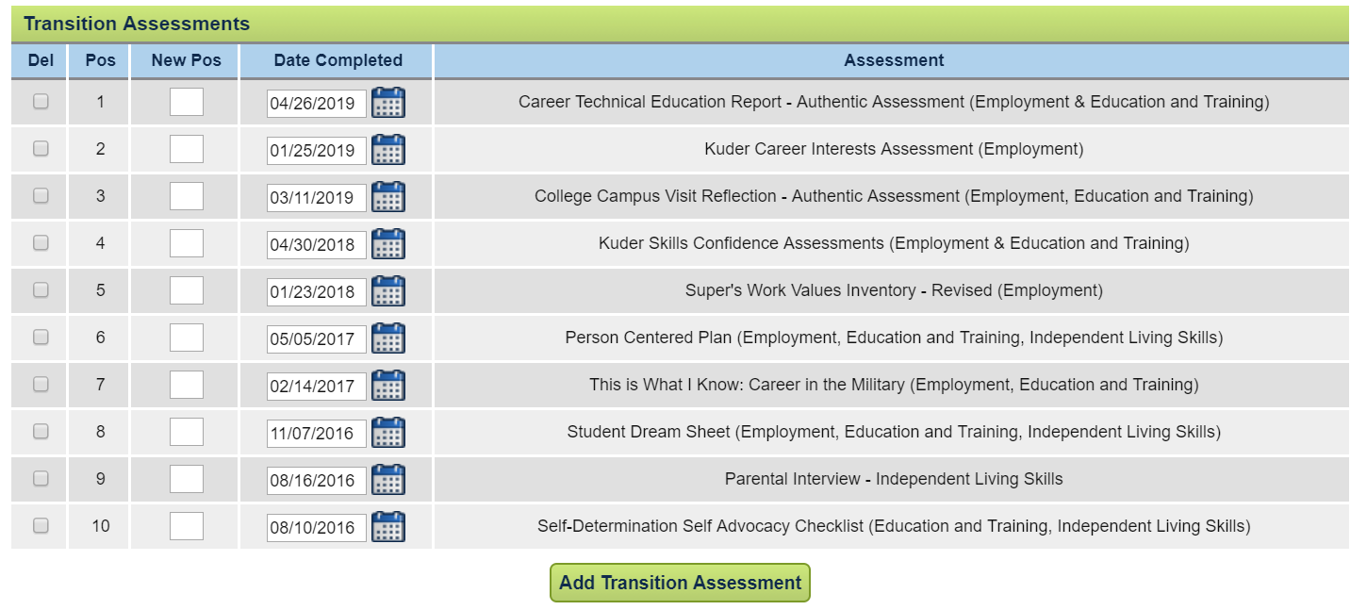

Summary of Findings from Age-Appropriate Transition:

Independent Living: On the Self – Determination Self Advocacy Checklist given on 08/10/2021, it was determined that an independent living goal was not needed. CCC reviewed and determined at the ACR review on 05/06/2019 that a goal for this domain is not needed at this time, because Eduardo continues to show age-appropriate skills (strength). He performs daily chores at home: making his bed, feeding and walking the family dog, and working a part time job on a farm baling hay (interest and preference). He is aware of his medical needs and when to make appointments but this is still overseen by his parents at this time. He would like to continue to look at options for living more independently after graduation (interests and need).

Employment: On the Career Interests Assessment given on 01/25/2022 it showed interests in 5 areas. Eduardo narrowed the search down to his interest areas of agriculture and construction as well as natural resources. Eduardo researched the areas of construction after the assessment was completed. He feels that his strengths include being able to solve problems and work with his hands to develop or construct objects. His interests and preferences are working with his hands and outdoors. He has also identified a need to understand how to approach a boss or supervisor when on the job and not understanding what is expected next or how to ask for assistance.

Education/Training: On 04/26/2022 reported through the Career and Technical Education Report completed by the building trade teacher. Through the report, strengths were identified as: working with others, following directions. He was able to have an honest conversation with TOR during the review of the report to identify a need to investigate college interests. He reported that he would prefer going for a two-year program/certification. He is concerned his writing is not great, and he might have trouble in college.

PREVIOUS SUMMARY (some teachers leave in, others take out – district decision)
Independent Living: On the Self – Determination Self Advocacy Checklist given on 08/10/2020, Eduardo answered yes on many of the questions answered. He reported that he is able to identify his strengths quickly. He reported that he does have times that he has needs, but does not always know how to advocate for himself. Eduardo reported that when he gets older he is interested in living more independently, but is not sure what that will look like. He reported that he does pretty well with organizing and turning in homework and completing study skills for school. He also identified that he likes working in groups with peers (preferences).

Employment: On the Skills Confidence Assessment given on 04/30/2019 identified 5 National Career areas of interest. Eduardo strengths include working with his hands, being outdoors and finishing projects. He would like to continue working with his hands. Eduardo identified that he prefers looking at areas of interest in agriculture and construction.

Education/Training: On the Skills Confidence Assessment given on 04/30/2019 it noted that the areas of interest for Eduardo included technical assistance and training. Eduardo told his teacher that he would like to think about college, because he had not thought it was a reality because of his writing ability until completing the survey (need).

July 2022
Copyright ©️ 2022 Center on Community Living and Careers

