Once you make the determination that an Independent Living Postsecondary Goal is not needed, there must be a citation in the results of age-appropriate transition assessments that indicates when and how that decision was made. You must always include the original assessment utilized to make the determination (name of the assessment and date it was given). You may add to the citation if you wish to show continued growth.

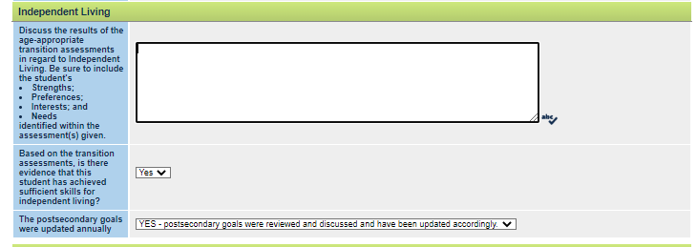

The following are examples of statements that could be used to describe in the results of age-appropriate transition assessments to explain why an Independent Living Postsecondary Goal is not needed.

Based upon the Adolescent Autonomy Checklist (dated 2/25/2022), Isaiah takes care of his own personal needs, understands what to do when he isn’t feeling well or needs help, utilizes community resources (library, post office, bank), and uses his own cell phone. Isaiah participates in activities at home that demonstrate age-appropriate independent living skills such as preparing simple meals, taking his own medicine, and making basic repairs to various household items. The CCC agrees that Isaiah does not need an Independent Living Postsecondary Goal at this time.

Jasmine and her mom completed the Planning for Community Living Worksheet on 3‐22‐2022.
They both believe that Jasmine will be able to shop, cook, do laundry, clean and take care of
all personal needs as an adult. They feel that she may need informal/family support in
the areas of budgeting and paying bills due to her ADHD and anxiety. This information, along with Jasmine’s current skill sets indicates that she does not need an Independent Living Postsecondary Goal.
July 2022

Copyright ©️ 2022 Center on Community Living and Careers

