MAKING THEM COORDINATED AND STUDENT FOCUSED

Transition Services and Activities: (Should support the student
making progress toward their long term, post-secondary goals; need to be unique to the student)
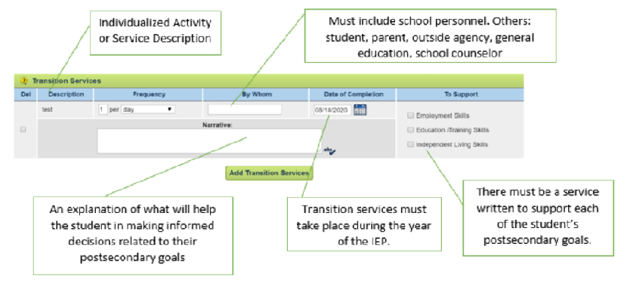

Postsecondary goal statements:
Employment – I will get a job working outside.
Education/training – I will go to technical or trade school.

Description: Job Research (supports employment and education/training)
Narrative: Eduardo will research careers on-line that involve working outside. He will determine the general job description, salary, education required, and job outlook for each job researched.

Description: Practice Job Interview Questions (supports employment)
Narrative: Eduardo will role play a job interview by practicing interview questions. It was recommended as a good activity for Eduardo in Indiana Career Explorer. Eduardo needs support in answering questions appropriately. This activity will support Eduardo’s postsecondary goal of finding employment in a job that is outside.

Description: Career Research (supports employment and education/training)
Narrative: Eduardo will research careers on-line that involve working outside. He will determine the general job description, salary, education required, and job outlook for each job researched.

Description: Participate in Computer Coding Club (supports employment and education/training)

Narrative: Isaiah will join the Computer Coding Club at school to connect to his interest and career goal in computers. In the computer club Isaiah will participate in computer coding projects and visit colleges and universities that offering computer coding programs.

Description: Create a Career Presentation (supports employment and education/training)
Narrative: With the assistance from Pre-ETS, Isaiah will create a presentation describing his interest and knowledge with computer and technology. He will use this presentation as part of his transition portfolio.

Description: Interview a writer (supports employment)
Narrative: Jasmine will interview a writer from our local newspaper to learn about their job. The teacher of record will work with Jasmine before the interview to discuss appropriate questions to ask the writer.

Description: Basketball Team Stat Internship (supports employment)
Narrative: Josie will participate in a job internship with the local college girls’ basketball team. Using her Dynavox calculator, Two Big Red Buttons, and the support of her job coach, Josie will keep track of points and rebounds for the team during home basketball games.

Description: Career Exploration (supports employment)
Narrative: Amara will choose and watch 5 different career videos about jobs in the art field. She will complete an activity form over each that will help her determine the positives and negative of each career.

Description: Nutrition and Wellness Class (supports Independent Living)
Narrative: Tyler will take the Nutrition and Wellness Class in the spring semester to learn skills needed to prepare meals and snacks. This is identified as part of his postsecondary independent living goal.

Copyright ©️ 2022 Center on Community Living and Careers

